**Pandas for Data Processing**

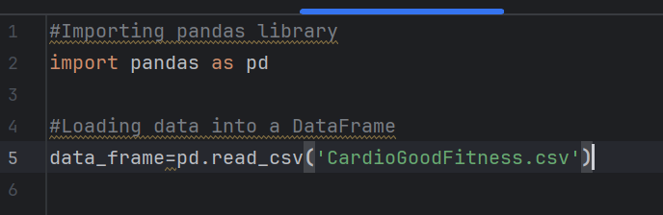

**Reading CSV Data using Pandas**

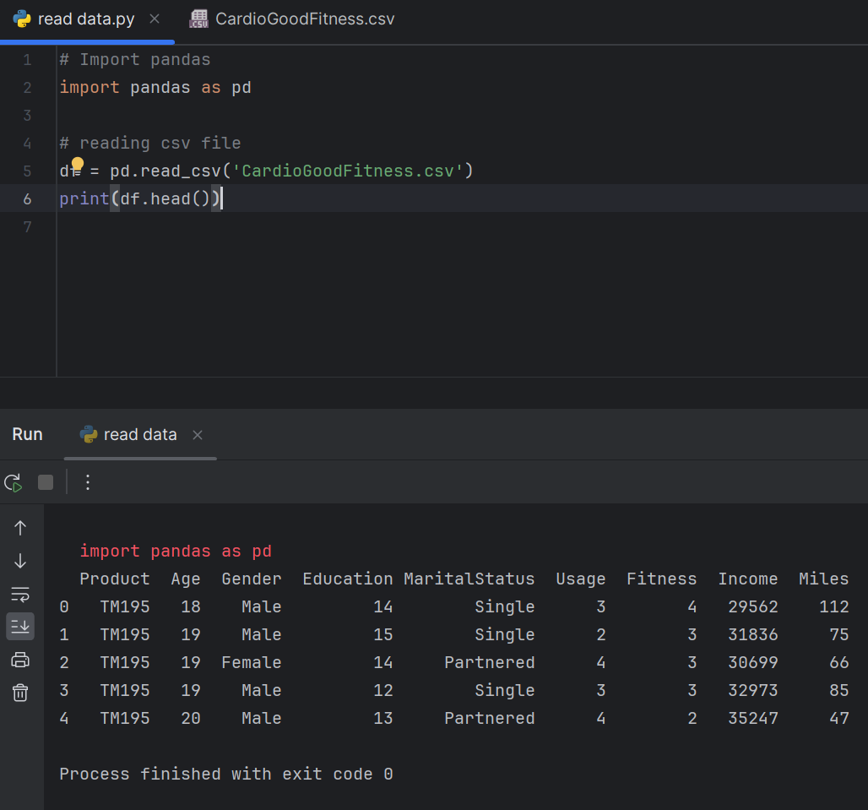

**Read Data from CSV Files to Pandas Dataframes**

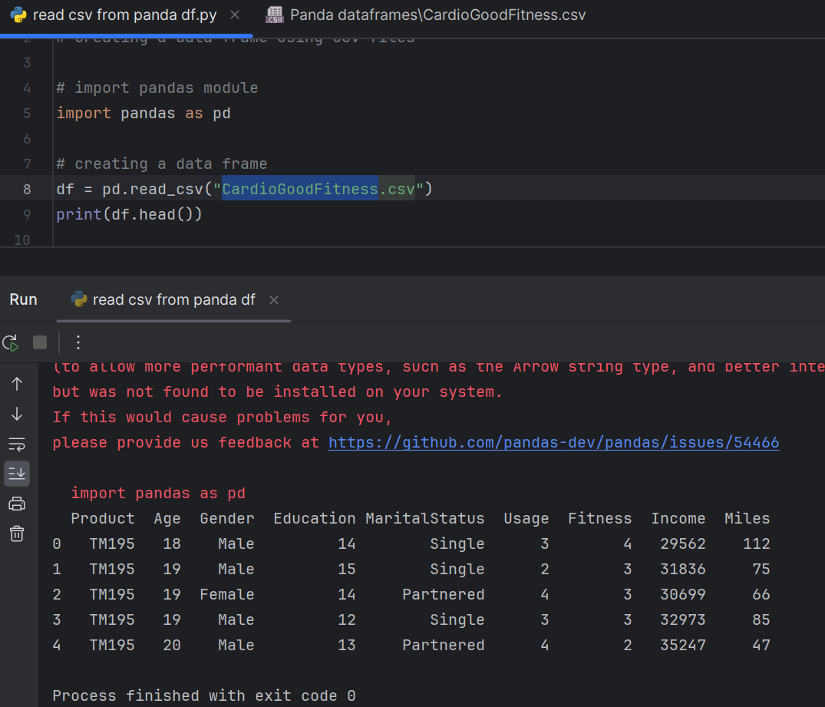

**Filter Data in Pandas Dataframe using query**

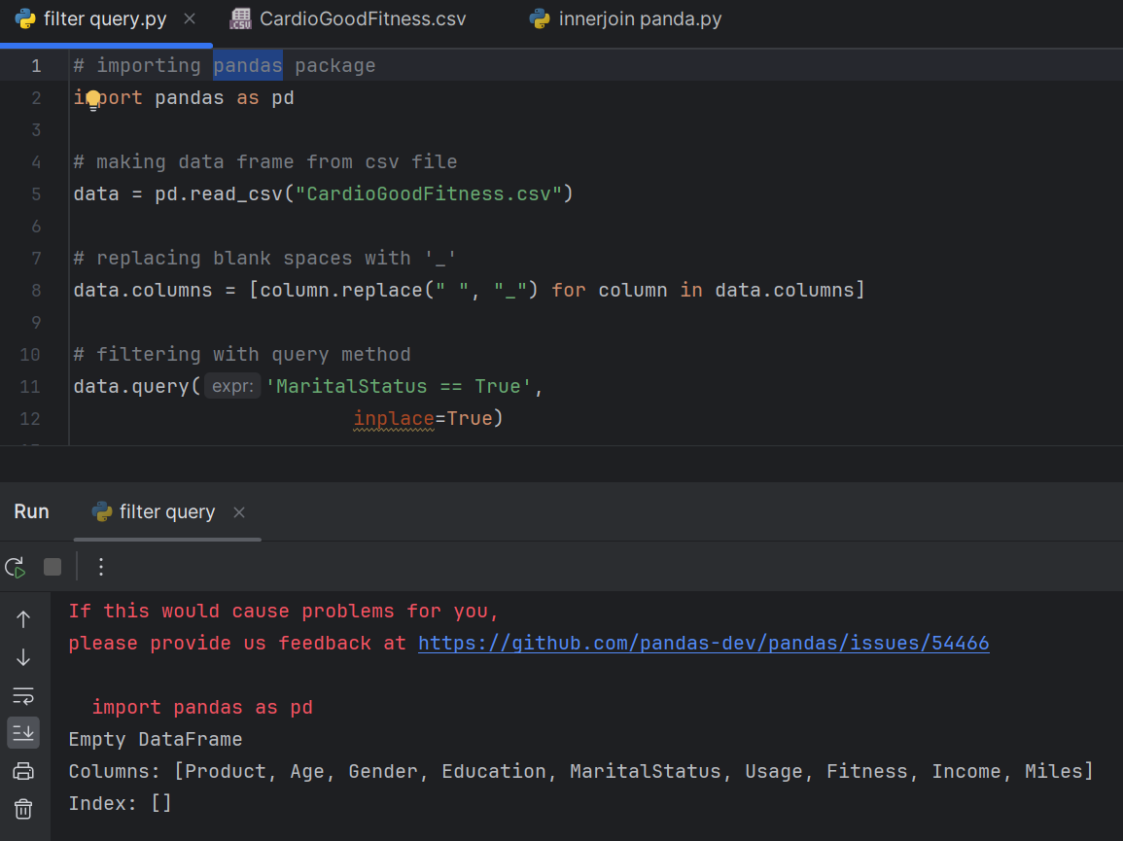

**Get Count by Status using Pandas Dataframe APIs**

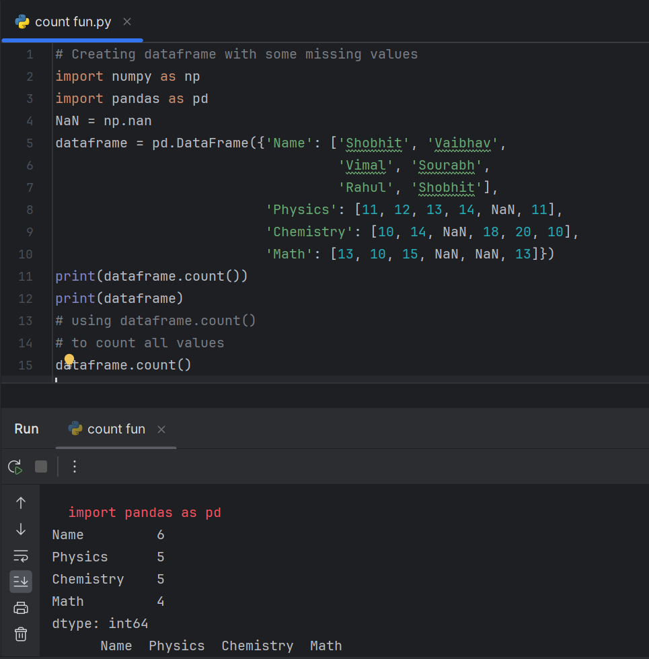

**Get count by Month and Status using Pandas Dataframe APIs**

**Create Dataframes using dynamic column list on CSV Data**

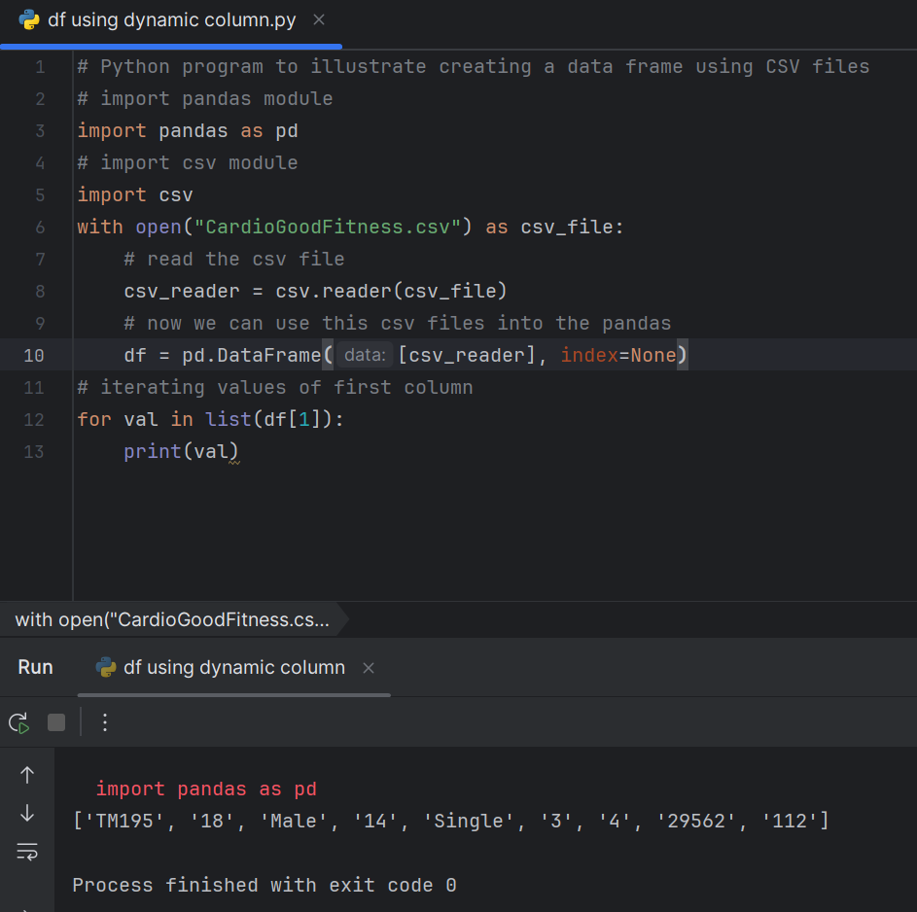

**Performing Inner Join between Pandas Dataframes**

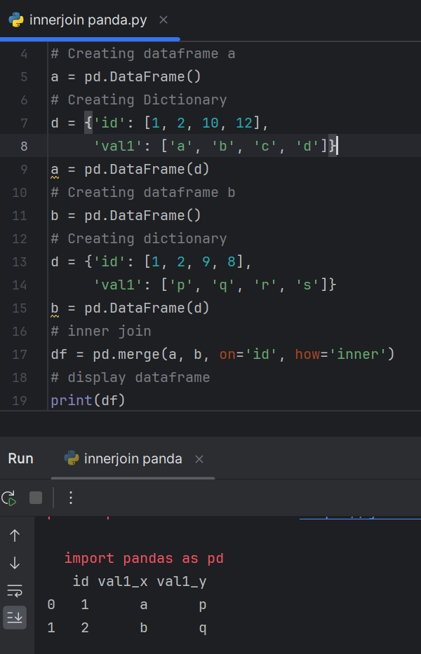

**Perform Aggregations on Join results**

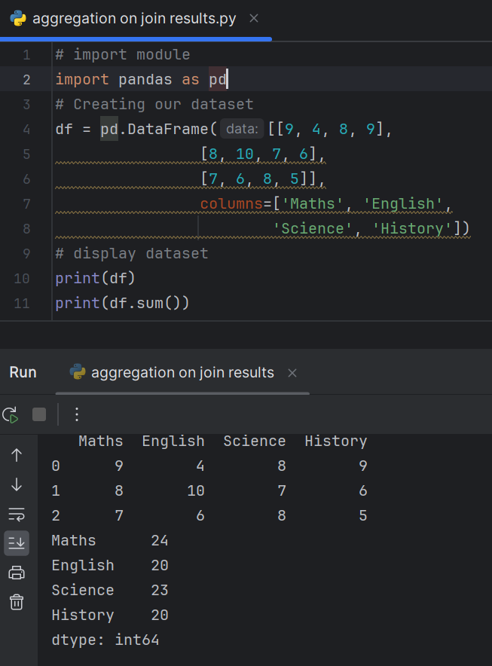

**Sort Data in Pandas Dataframes**

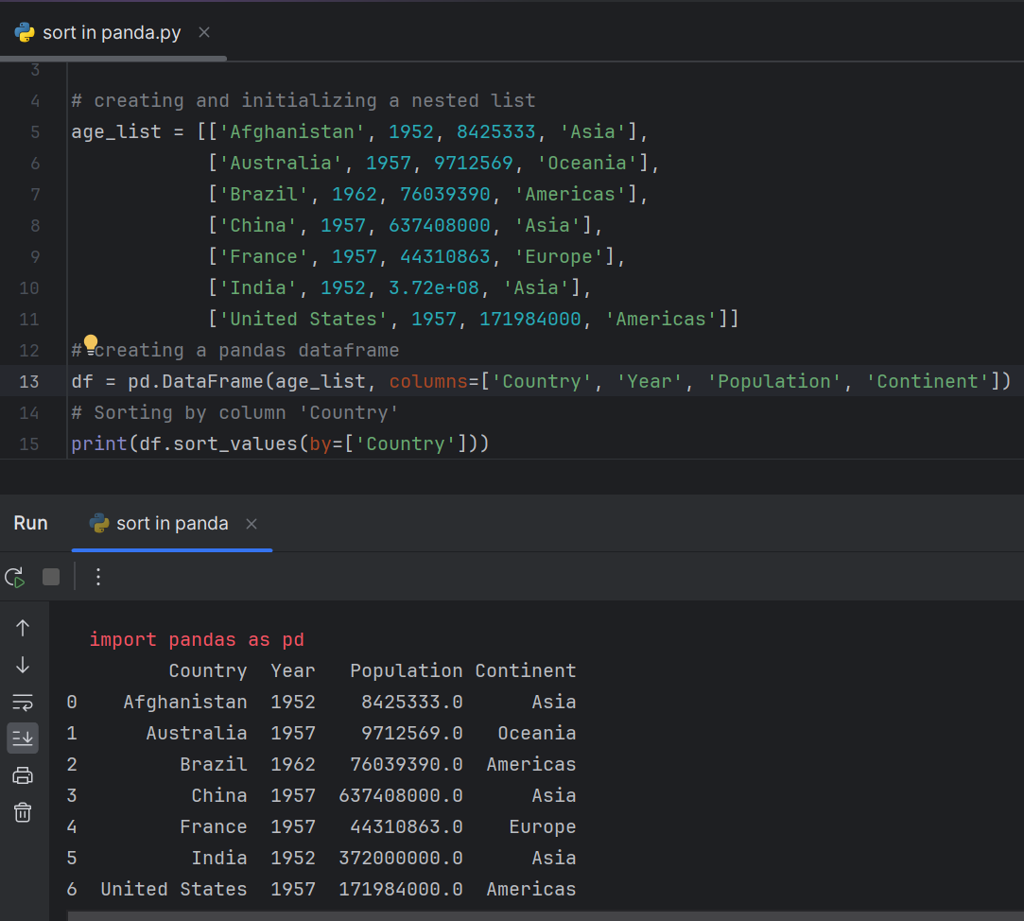

**Writing Pandas Dataframes to Files**

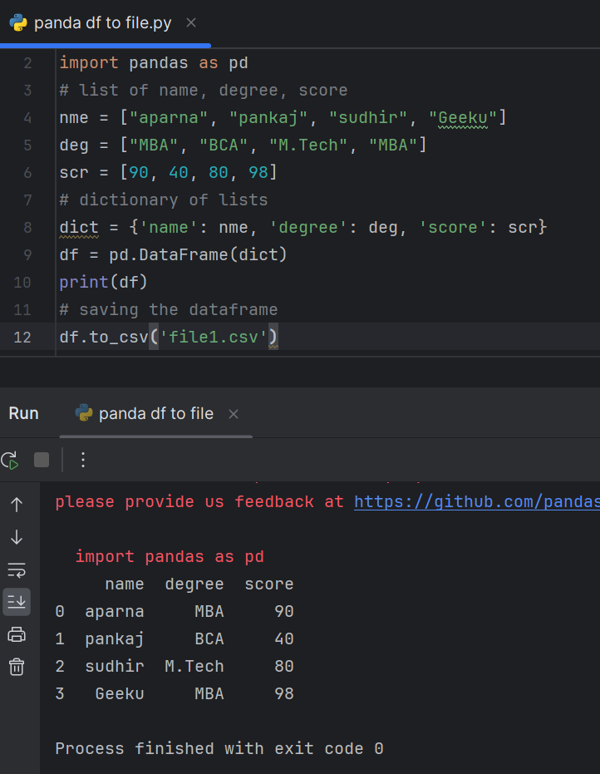

**Write Pandas Dataframes to JSON Files**

